**Subquery In My SQL**

**Create Table Student**

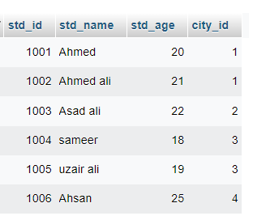

**Create Table City**

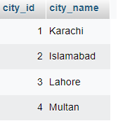

**1-Show the data of students which lives in karachi**

**2-Insert Student data in a new table which lives in karachi**

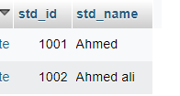

**3- Delete Student which lives in Islamabad**

**4-Update student name which lives in multan**